1. Get access to the repo.
   1. <https://drive.google.com/drive/folders/15X6AKKwtoipcvED6UCcdmhYNPBn4n21U?usp=sharing>
2. Import the source code into the workspace.
3. Understand the functionality of the system.
   * 1. Starting from the main class
     2. Run the program
     3. List the major functionality of the system.
4. Understand the components of the system
   1. The components that realize the functionality of the system.
5. Associate the identified components with classes of the projects.
   1. Use oxygen to generate a list of code level classes.
   2. Create a catalog using the structure in the screenshot:

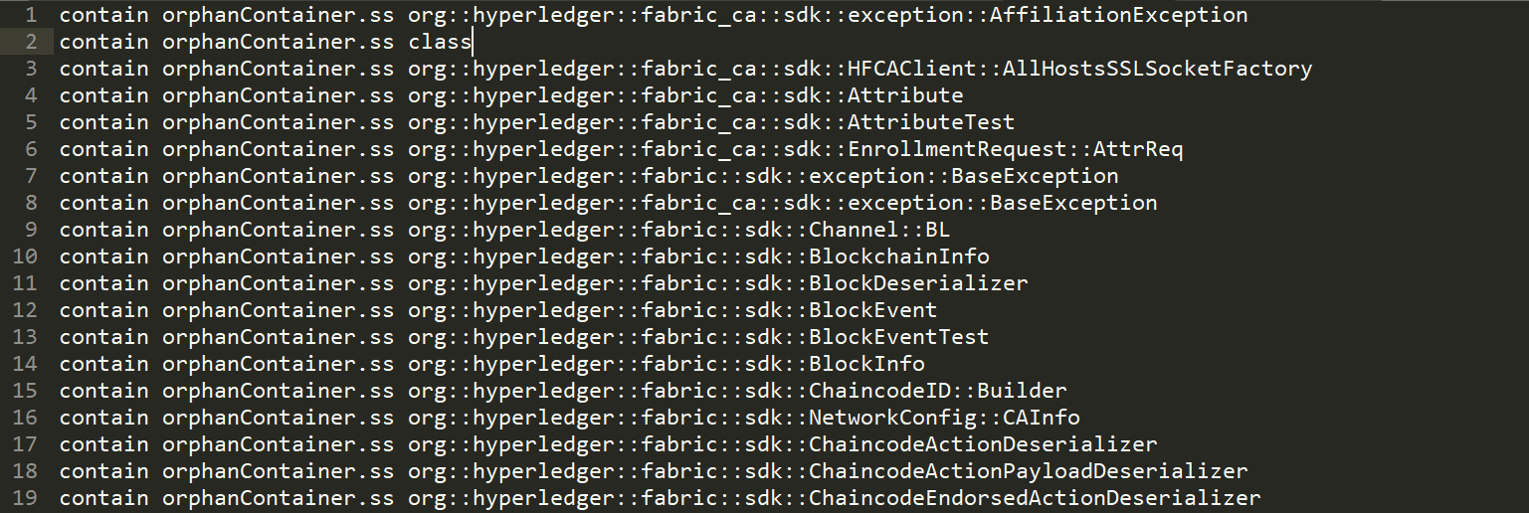

1. Send the email about the classification.